# Task

You are challenged to design a thing. That thing must show your design and engineering skills and has the following constraints:

* It should take no longer than 3 hours 40 minutes of class time to product
* It must be a flatpack design that can be cut out a single piece of A4 cardboard.
* It must be something mechanised and controlled by an arduino.
* You must have a concept design for what the end product should look like. These concept designs must be sketched on pencil and paper.
* You must have boxes and arrow design for the code of an arduino
* Your must have a CAD design that shows how the entire project will come together
* You must have a diagram from CAD that prints for the Laser Cutter.
* Your overall output must be sufficient for a third party to build your design
* Your overall design must feel like it is appropriately scaled to reality.

Note you must also submit:

A “script” of how you respond to the following questions:

* When designing a system, how do you present/communicate complex ideas to technical and/or non-technical users?
* Provide an example of how your design provides some level of innovative (to you) or high quality design and how you approached this concept.

Example of a thing:

Concieve and design a Railway crossing with a boom arm that is appropriatly scaled so it looks appropriate in size to a real railway crossing with a boomarm.

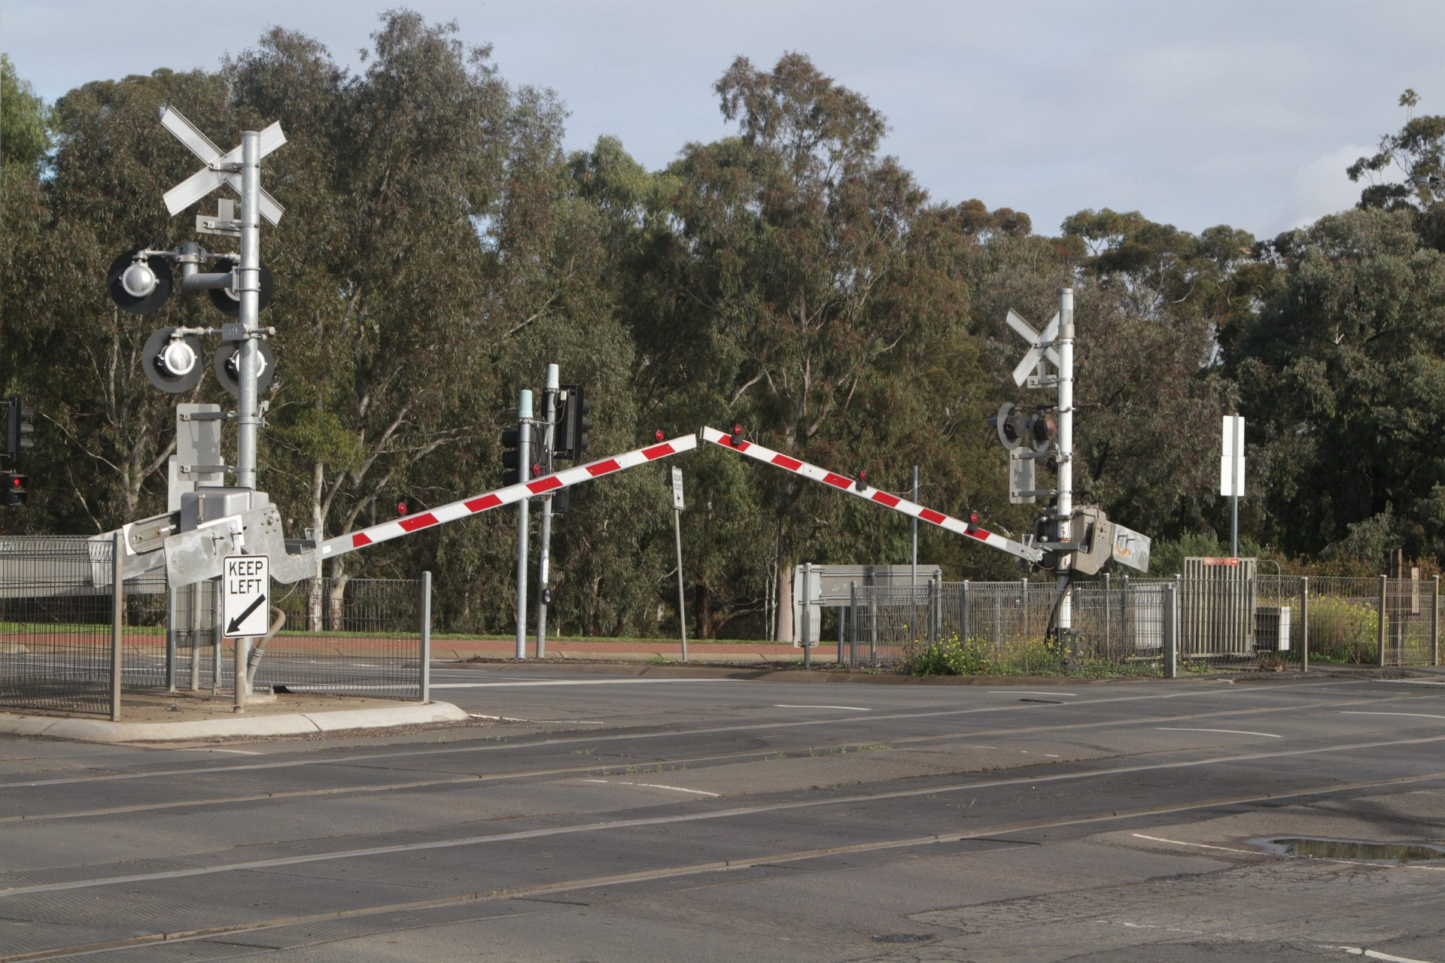

## Instruments of assessments

At the heart of enegineering is the ability to articulate complex ideas to both technical and non-techncial users. In this unit, we use CAD tools built up on on basic sketching and paper concepts.

### Assessment Guide

* Is your design likely to be built by someone else who can’t deviate from the plan?
* Have you got sketches?
* Have you thought how you are going make it work?
* Have you got boxes and arrows for code design?
* Have you got a CAD design?
* When you bring it down to a drawing, does it all fit on an A4 page?
* The script

## Task 1: Evidence Guide

## Rubric

|  |  |  |  |  |  |  |
| --- | --- | --- | --- | --- | --- | --- |
|  | **Knowledge, Comprehension & Application** |  |  |  |  |  |
| **CRITERIA** | **EXPECTATIONS** | **POSS** | **STUDENT** | **GIVEN** | **MULTI** | **TOTAL** |
| **Submission of core material** | You have submitted a design for a mechatronic thing. At the minimum your submission contains   * sketches of your intended project * programming specifications * CAD design of the final product * A diagram for cutting | 2 | __/2 | __/2 | A x2  T x1 | A __/ 4  T __/ 2 |
| **A Script/notes for your interview** | You have submittee your notes/script that you intend to use for your interview. | 2 | __/2 | __/2 | A x2  T x1 | A __/ 4  T __/ 2 |
| **Attendence to Interview** | You attended the interview | 2 | __/2 | __/2 | A x2  T x1 | A __/ 4  T __/ 2 |
|  | **Analysis, Synthesis & Evaluation** |  | | **SUBTOTAL** | | **A __ / 12**  **T__ / 6** |
| **Communicate complex ideas** | Both in your notes and in your interview, you expressed your nuanced knowledge and understaning of presenting/communicate complex ideas for both technical and non-technical users. | 4 | __/4 | __/4 | - | __/ 4 |
| **Innovative/high-quality design** | Both in your notes and in your interview, you highlighted your ability to think of, considere, or implement novel/innovative/high-quality concepts. You express a nuanced knowledge of the quality/innovative nature of your design and how you made informed decisions on how to implement them. | 4 | __/4 | __/4 | - | __/ 4 |
| **Technical Design** | Your deisgn is clearly intended for a third party to build the system from beginning to end within the time period. | 4 | __/4 | __/4 | - | __/ 4 |
|  | **Submission Guidelines** |  | | **SUBTOTAL** | | **__ / 12** |
| **Overall presentation quality** | Overall, the presentation **was well presented**. **Ideas were structured** well and **made sense within their contexts**. Answers were **direct and to the point**. | 4 | __/4 | __/4 | - | __/ 4 |
|  |  |  | | **SUBTOTAL** | | **__ / 4** |
|  | DAYS LATE ___/7 = ___% |  |  | **FINAL** | | **A __/28 T __/22** |

## Rubric sections

##### Section 1: Knowledge Comprehension and Application

This section of the rubric consists of the required elements of the assignment. Students should take special care to include ALL these elements as they are often extended in the following sections

##### Section 2: Analysis, Synthesis, and Evaluation.

This section will evaluate your ability to include critical thinking and justification elements into your work. Often the requirements for extension are not explicitly given, so it will be up to you to decide how best to demonstrate what you have learned beyond the required unit goals and curriculum. Items such as 3D models, pictures, drawings, diagrammatic responses, notes, evidence of problem-solving, advanced programming concepts, elegant responses, media, etc., are all available options.

##### Section 3: Submission Guidelines

Students are expected to provide a submission that fulfils the requirements listed in style guides while also submitting at an appropriate quality. Be aware that points in this section could be 2- or 4-point items. Treat them accordingly.

## Submission

All submission items should be stored in an appropriate format. For example, code must be stored in a programmatical format so it can be evaluated (**images of code or code copied and pasted into a document may not be marked**)

Evidence of working material must be recorded where appropriate. For example, to show how your robot meets a requirement, you must submit a recording of it completing that requirement. Similarly, if you need to show how your program can download a file from the internet and crack a password, you must submit a recording of it doing that.

Ask the teacher if you are unsure if an element needs to be recorded**.**

All materials must be submitted to Google Classroom.

Students are responsible for keeping backups/master copies.

## **Scoring Notes**

Formatting for all typed/written assessments should be as follows:

|  |  |  |  |  |  |  |
| --- | --- | --- | --- | --- | --- | --- |
| **Google Doc** | 11-12 Pt | 1.15-1.5 Line Spacing | 1 Space between paragraphs | Spelling and Grammar “Soft Limit” | In-Text Citations with footnotes | Title Page/Slide:   * Name * Date * Class * Aim * Assessment title |
| **Slides** | 10-12 pt. font text  14-24 pt. font titles | 1.0 1.15 Line Spacing | Bullet Points Preferred | Word Count per slide >100-110 “Soft Limit.” | Approved Templates and Themes |
| **Python** | We apply the following style guide to Python files. However, in general, most programs follow this overall layout.    [PEP 8: The Style Guide for Python Code](https://pep8.org/) | | | | | |
| **Arduino**  **C/C++** | We apply the following style guide to C/C++ files. However, in general most programs follow this broad layout.    I accept both K&R and K&R alternative bracing format. As long as it is consistent in your file.  [Arduino Style Guide for Creating Libraries | Arduino Documentation | Arduino Documentation](https://docs.arduino.cc/learn/contributions/arduino-library-style-guide) | | | | | |
| **Markdown** | We apply the following style guide to markdown documents. However, in general, most documents follow some variation of the following layout:    <https://github.com/google/styleguide/blob/gh-pages/docguide/style.md> | | | | | |

“Soft Limits” are not rigidly defined limits and will be assessed on a case-by-case basis. Ask for clarification on specific tasks

## Possible Scoring Groups are out of 2 or 4 Points.

##### 2-Point Criteria - Knowledge and Understanding

Criteria assessed as 2-Points are classified as Knowledge and Understanding criteria. These will examine and evaluate a student’s ability to effectively state facts and define terms and concepts. Analysis and synthesis of the information will not be assessed through these criteria.

|  |  |  |  |
| --- | --- | --- | --- |
|  | **0 Points** | **1 Point** | **2 Points** |
| **2 Point Criteria** | **Not present** or **not able to be assessed** as the required criteria | Item is presented but **does not meet expectations** for quality, rigour, or detail. | Item is presented and **does meet expectations** for quality, rigour, or detail |

##### 4-Point Criteria - Analysis and Synthesis and Expert Review

To show true mastery of your developing skills, students must show that they can go beyond simple repetition of the given tasks or an explanation of processes. Students will demonstrate their ability to show higher-order thinking through analysis, evaluation, or linking multiple fields of learning to solve problems in novel ways.

## Analysis and Synthesis

Analysis and Synthesis components evaluate a student’s ability to effectively review data and understandings and develop these into a coherent and relevant statement. Analysis refers to the generating of thoughts from interpreting the data. In contrast, synthesis combines experience from one area with other pertinent knowledge to develop an original and compelling solution.

|  |  |  |  |  |  |
| --- | --- | --- | --- | --- | --- |
|  | **0 Points** | **1 Point** | **2 Points** | **3 Points** | **4 Points** |
| **4 Point Criteria** | **Not present** or **not able to be assessed** as the required criteria | Evidence is presented and explained. However, it **does not show appropriate evidence of higher-order thinking** such as analysis, evaluation, or synthesis. | Evidence is presented and **shows appropriate evidence of higher-order thinking** such as analysis, evaluation, or synthesis. | Evidence is presented and **exceeds expectations for evidence of higher-order thinking** such as analysis, evaluation, or synthesis.  **-or-**  Item is presented and shows appropriate evidence of higher-order thinking such as analysis, evaluation, or synthesis and **exceeds expectations for quality or rigour** of understanding of the selected mastery. | Evidence is presented and **exceeds expectations for evidence of higher-order thinking** such as analysis, evaluation, or synthesis. **Additionally, this item exceeds expectations for quality or rigour** of understanding of the selected mastery. |

##### Expert Review

Expert Reviews evaluate a student’s ability to build solutions using the skills taught during the semester. Criteria assessed as 4-Points are classified as Analysis and Synthesis criteria. These will examine and evaluate a student’s ability to effectively review data and understandings and develop these into a coherent and relevant statement. Analysis refers to the generating of thoughts from interpreting the data. In contrast, synthesis combines experience from one area with other pertinent knowledge to develop an original and compelling solution.

|  |  |  |  |  |  |
| --- | --- | --- | --- | --- | --- |
|  | **0 Points** | **1 Point** | **2 Points** | **3 Points** | **4 Points** |
| **4 Point Criteria** | **Not present** or **not able to be assessed** as the required criteria | Evidence is presented and broadly solves the problem. However**, the evidence does not show appropriate mastery** upon review. | Evidence is presented and broadly solves the problem. On review, it **does show appropriate evidence** of mastery. | Evidence is presented and solves the specific problem. On review, the evidence **shows understanding beyond expected mastery**.  **-or-**  Item is presented and broadly solves the problem. On review, it does show appropriate evidence of mastery and is **done so in a well-constructed or design method** that clearly shows higher levels of understanding**.** | Evidence is presented and solves the specific problem. On review, **the evidence shows understanding well beyond expected mastery** and is **done so in a well-constructed or designed method** that clearly indicates higher levels of understanding. |

##### Multiplier

Criteria will be combined with a **Multiplier**. While each criterion will be scored on the 0-1-2-4 scale, the multiplier will attach relevant worth to each criterion. Be aware of these multipliers and dedicate appropriate time to ensure you achieve your best result.

## Achievement Standards:

## Evidence of higher-order learning:

What is it that I mean by “higher-order thinking”?

It means I want you to go beyond replicating what we do in class. I want you to dig into your brain and understand why you did something, what about it was great, and what could be improved.

Why is this important? Reflective thinkers can go beyond what they are taught and can customise their learning to ben

